**EXTENDED PARSER**

**Ex 1**: Modify file example2.kpl so that it causes the error “Invalid arguments”

* Input a word behind the RPAR in line 14

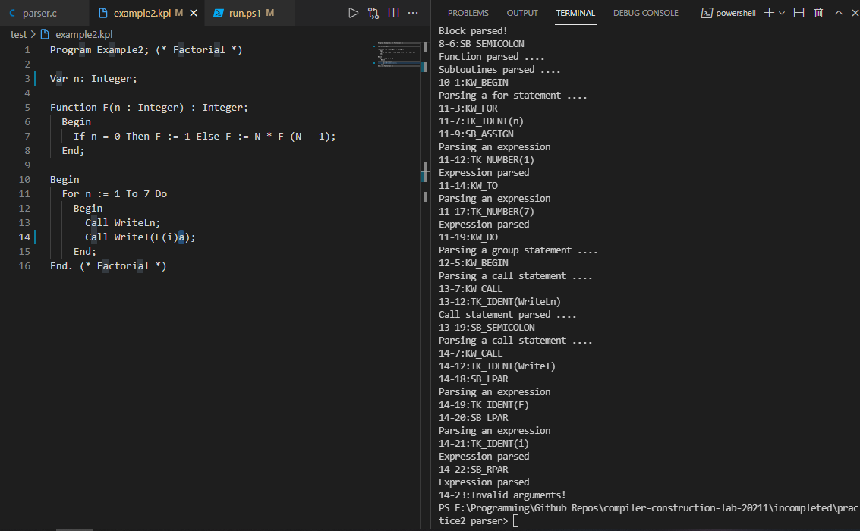

**Ex 2**: Suppose syntax of declarations in KPL follows the following rules

Block ::= Declarations Block2

Declarations::= ConstDecls Declarations|TypeDecls Declarations VarDecls Declarations|SubDecls Declarations|?

Constdecls ::= KW_CONST ConstDecl ConstDecls2

ConstDecls2::= ConstDecl ConstDecls2

ConstDecls2::= eps

TypeDecls ::= KW_TYPE TypeDecl TypeDecls2

TypeDecls2 ::= TypeDecl TypeDecls2

TypeDecls ::= eps

VarDecls ::= KW_VAR VarDecl VarDeclrs2

VarDecls2 ::= VarDecl VarDecls

VarDecls2 ::= eps

SubDecls ::= FunDecl SubDecls|ProcDecls SubDecls|?

FunDecl ::= KW_FUNCTION TK_IDENT Params SB_COLON BasicType SB_SEMICOLON Block SB_SEMICOLON

ProcDecl ::= KW_PROCEDURE TK_IDENT Params SB_SEMICOLON Block SB_SEMICOLON

Block2 ::= KW_BEGIN Statements KW_END

Modify relevant functions in your parser to match the new rules